Proposed AVIRIS-NG website page name: “Greenhouse gas mapping”

Proposed location: Replace “Benchmark Methane Data” sidebar with “Greenhouse gas mapping”

Proposed text:

Background

Greenhouse gases strongly absorb electromagnetic radiation in many parts of the infrared spectrum. Methane (CH₄) and carbon dioxide (CO₂) have distinct absorption features in in the shortwave infrared (1400-2500nm). Reflected solar radiance measured by airborne imaging spectrometers AVIRIS-NG and AVIRIS-C can be used to measure increased concentrations of atmospheric methane and carbon dioxide. The plots below (Figure 1, from Thorpe et al. 2017) show the “fingerprints” of methane, carbon dioxide, and water vapor absorption that allows their concentration to be estimated.

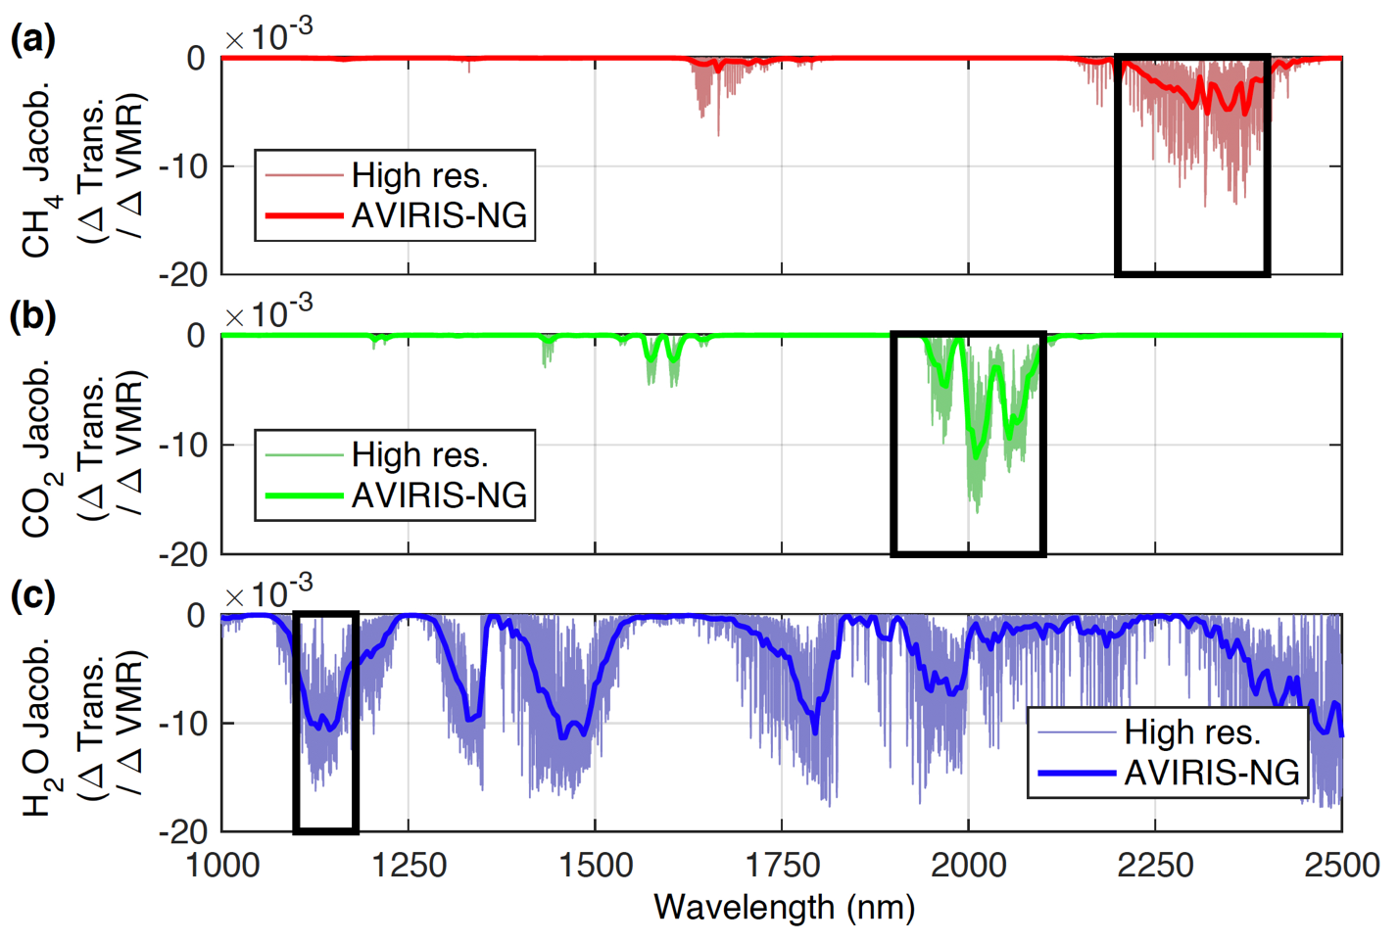

Figure 1. High resolution and AVIRIS-NG absorption spectra for (a) methane (CH₄; red), (b) carbon dioxide (CO₂; green), and (c) water vapor (H₂O; blue). AVIRIS-NG retrieval windows are indicated by the black outlines. See Thorpe et al., 2017 for additional details.

Early work demonstrated detection of methane and carbon dioxide plumes from AVIRIS-C data. Roberts et al. (2010) detected methane plumes from the Coal Oil Point seep field off the coast of California, and Dennison et al. (2013b) detected carbon dioxide plumes from multiple fossil fuel power plants. Subsequent research has developed algorithms that retrieve the enhancement of methane and carbon dioxide concentration above background from AVIRIS-NG data (Thorpe et al., 2014, 2017; Thompson et al., 2015; Cusworth et al., 2019; Foote et al., 2020), which allows for estimates of emissions rates (Frankenberg et al., 2016; Duren et al., 2019). The figures below demonstrate retrieval of enhancements from AVIRIS-NG radiance data for a natural gas processing plant (Figure 2) and a coal power plant (Figure 3).

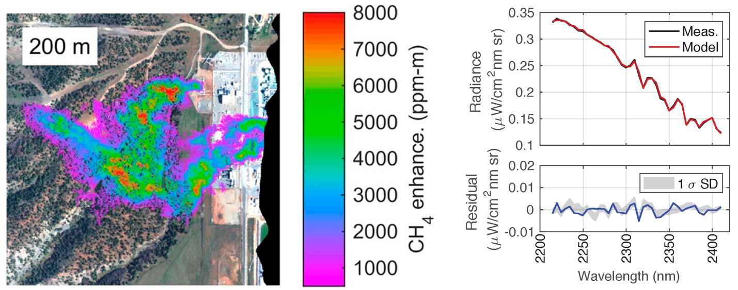
Figure 2. Methane plumes for a natural gas processing plant and an example of retrieval fit between AVIRIS-NG measured radiance (Meas.) and modelled radiance.

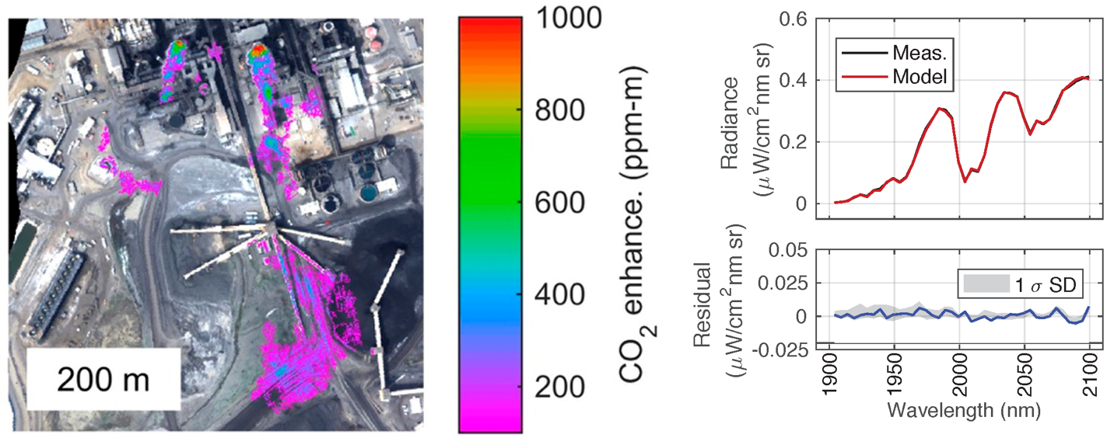
Figure 3. Carbon dioxide plumes from a coal power plant and an example of retrieval fit between AVIRIS-NG measured radiance (Meas.) and modelled radiance.

Since 2015, a number of AVIRIS-NG campaigns for characterizing point source methane emissions have been completed in Colorado, New Mexico, California, Alaska, Canada, and Texas (Table 1). The Four Corners Methane Campaign characterized over 250 individual methane plumes associated with coal bed methane extraction, with the top 10% of emitters responsible for half of the total observed point source contribution (Frankenberg et al., 2015). The California Methane Survey (Duren et al., 2019) identified and quantified point source emissions from over 550 energy, waste management, and agriculture sources. Estimated emissions from methane point sources in California are estimated at 0.618 TgCH₄ yr⁻¹ (95% confidence 0.523-0.725), which is equivalent to 34-46% of 2016 California methane inventory. Landfills were responsible for 41% of the observed methane point-source emissions in California, followed by dairies (26%) and the oil and gas sector (26%).

Methane data from the California Methane Survey is available on the ORNL DAAC and through the Methane Source Finder web portal. Additional studies have explored the underground gas storage (Thorpe et al., 2020) and waste management (Cusworth et al., 2020a) sectors, improved retrieval algorithms (Foote et al., 2020), improved methods for estimating emission rates (Jongaramrungruang et al., 2020), and multi-tiered observing systems (Cusworth et al., 2020b).

With summer flights starting in 2017, the Arctic Boreal Vulnerability Experiment (ABoVE) has identified methane hotspots for 0.2% of the surveyed area that follow a two‐component power law as a function of distance from standing water (Elder et al., 2020). Methane hotspots decreased sharply over the first 40 m from standing water, and wide‐ranging methane fluxes at two thermokarst lakes mirror the patterns of remotely sensed hotspots.

These airborne campaigns have resulted in emission mitigation (Duren et al., 2019, Thorpe et al., 2020, Cusworth et al., 2020b) and facilitated studies to better understand the methane sensitivities of future orbital imaging spectrometers like EMIT (Ayasse et al. 2019), EnMAP, and other instruments (Cusworth et al., 2019). A full list of publications is provided below.

Table 1: Recent AVIRIS-NG methane campaigns
AVIRIS-NG methane campaign | Focus region | Objective | Dates
Four Corners Methane Campaign | Colorado, New Mexico | Identify and quantify methane point source emissions from energy sector | 4/19/15-4/23/15
California Methane Survey | California | Identify and quantify methane point source emissions from energy, waste management, and agriculture sectors | 9/16-11/16, 8/17-11/17, 9/18-10/18
Arctic Boreal Vulnerability Experiment (ABoVE) | Alaska, Canada | Characterize arctic methane hotspot patterns associated with proximity to standing water | 6/17-8/17, 7/18-8/18, 7/19-8/19
Texas Methane eXperiment (TexMeX) | Texas | Quantify energy sector emissions from Permian Basin | 9/19-10/19

While carbon dioxide emissions have not been the focus of AVIRIS-NG campaigns to date, many power plants have been overflown as part of campaigns in the US and India. Recent work has demonstrated retrieval of carbon dioxide emissions from power plants (Cusworth et al., in review).

Benchmark greenhouse gas datasets

The following benchmark datasets are intended as a useful tool for algorithm development and testing of greenhouse gas retrieval methods for imaging spectrometers.

2017 Benchmark Methane Data This dataset contains several AVIRIS-NG scenes from the 2015 Four Corners campaign with distinct methane plumes from oil and natural gas infrastructure.

2020 Benchmark Dataset for Methane and Carbon Dioxide Plumes [Provide link to new webpage “Benchmark Dataset for Methane and Carbon Dioxide Plumes”: https://avirisng.jpl.nasa.gov/benchmark_methane_carbon_dioxide.html]

This dataset contains ten AVIRIS-NG scenes from a variety of campaigns spanning 2015-2019. The scenes include methane plumes from oil and natural gas infrastructure, landfills, wastewater treatment, mining, and agricultural emissions. The scenes also include carbon dioxide plumes from four power plants.

Publications

2020:
Cusworth, D.H., Duren, R.M., Thorpe, A.K., Tseng, E., Thompson, D.R., Guha, A., Newman, S., Foster, K., Miller, C.E. (2020a). Using remote sensing to detect, validate, and quantify methane emissions from California solid waste operations. Environmental Research Letters, 15(5), 054012.

Cusworth, D.H., Duren, R.M., Yadav, V., Thorpe, A.K., Verhulst, K., Sander, S., Hopkins, F., Rafiq, T. and Miller, C.E., 2020b. Synthesis of Methane Observations Across Scales: Strategies for Deploying a Multitiered Observing Network. Geophysical Research Letters, 47(7), p.e2020GL087869.

Elder, C.D., Thompson, D.R., Thorpe, A.K., Hanke, P., Walter Anthony, K.M. and Miller, C.E., 2020. Airborne Mapping Reveals Emergent Power Law of Arctic Methane Emissions. Geophysical Research Letters, 47(3), p.e2019GL085707.

Foote, M.D., Dennison, P.E., Thorpe, A.K., Thompson, D.R., Jongaramrungruang, S., Frankenberg, C., Joshi, S.C. (2020). Fast and accurate retrieval of point-source methane emissions from imaging spectrometer data using sparsity prior. IEEE Transactions on Geoscience and Remote Sensing, 58, 6480-6492.

Guha, A., Newman, S., Fairley, D., Dinh, T.M., Duca, L., Conley, S., Smith, M.L., Thorpe, A., Duren, R.M., Cusworth, D. and Foster, K., 2020. Assessment of Regional Methane Emissions Inventories through Airborne Quantification in the San Francisco Bay Area. Environmental Science & Technology.

Rafiq, T., Duren, R.M., Thorpe, A.K., Foster, K, Patarsuk, R., Mille, C.E., Hopkins, F.M. (2020). Attribution of Methane Point Source Emissions using Airborne Imaging Spectroscopy and the Vista-California Methane Infrastructure Dataset. Environmental Research Letters.

Thorpe, A.K., Duren, R., Conley, S., Prasad, K., Bue, B., Yadav, V., Foster, K., Rafiq, T., Hopkins, F., Smith, M. and Fischer, M.L., 2020. Methane emissions from underground gas storage in California. Environmental Research Letters, 15(4), 045005.

2019:
Ayasse, A.K., Dennison, P.E., Foote, M., Thorpe, A.K., Joshi, S., Green, R.O., Duren, R.M., Thompson, D.R. and Roberts, D.A., 2019. Methane Mapping with Future Satellite Imaging Spectrometers. Remote Sensing, 11(24), p.3054.

Cusworth, D.H., Jacob, D.J., Varon, D.J., Miller, C.C., Lu, X., Chance, K., Thorpe, A.K., Duren, R.M., Miller, C.E., Frankenberg, C., Randles, C.A. (2019). Potential of next-generation imaging spectrometers to detect and quantify methane point sources from space. Atmospheric Measurement Techniques.

Duren, R.M., Thorpe, A.K., Foster, K., Rafiq, T., Hopkins, F.M., Yadav, V., Bue, B.D., Conley, S., Colombi, N., McCubbin, I., Frankenberg, C., Thompson, D.R., Falk, M., Herner, J., Croes, B., Green, R.O., Miller, C.E. (2019). California’s methane super-emitters. Nature.

Jongaramrungruang, S., Frankenberg, C., Matheou, G., Thorpe, A.K., Kuai, L., Thompson, D.R., Duren, R. M. (2019). Towards accurate methane point-source quantification using high spatial resolution spatial methane mapping. Atmospheric Measurement Techniques.

Thompson, D.R., Guanter, L., Berk, A. et al. Retrieval of Atmospheric Parameters and Surface Reflectance from Visible and Shortwave Infrared Imaging Spectroscopy Data. Surv Geophys 40, 333–360 (2019). https://doi.org/10.1007/s10712-018-9488-9.

2018:
Ayasse, A.K., Thorpe, A.K., Roberts, D.A., Funk, C.C., Dennison, P.E., Frankenberg, C., Steffke, A., Aubrey, A.D. (2018). Evaluating the effects of surface properties on methane retrievals using a synthetic Airborne Visible/Infrared Imaging Spectrometer Next Generation (AVIRIS-NG) image. Remote Sensing of Environment, 215, 386-397.

2017:
Krautwurst, S., Gerilowski, K., Jonsson, H.H., Thompson, D.R., Kolyer, R.W., Iraci, L.T., Thorpe, A.K., Horstjann, M., Eastwood, M., Leifer, I., Vigil, S.A. (2017). Methane emissions from a Californian landfill, determined from airborne remote sensing and in situ measurements. Atmospheric Measurement Techniques, 10(9), 3429.

Thorpe, A.K., Frankenberg, C., Thompson, D.R., Duren, R.M., Aubrey, A.D., Bue, B.D., Green, R.O., Gerilowski, K., Krings, T., Borchardt, J., Kort, E.A. (2017). Airborne DOAS retrievals of methane, carbon dioxide, and water vapor concentrations at high spatial resolution: Application to AVIRIS-NG. Atmospheric Measurement Techniques, 10(10), 3833.

2016:
Frankenberg, C., Thorpe, A.K., Thompson, D.R., Hulley, G., Kort, E.A., Vance, N., Borchardt, J., Krings, T., Gerilowski, K., Sweeney, C., Conley, S. (2016). Airborne methane remote measurements reveal heavy-tail flux distribution in Four Corners region. Proceedings of the National Academy of Sciences, 201605617.

Thompson, D.R., Thorpe, A.K., Frankenberg, C., Green, R.O., Duren, R., Guanter, L., Hollstein, A., Middleton, E., Ong, L., Ungar, S. (2016). Space‐based remote imaging spectroscopy of the Aliso Canyon CH4 superemitter. Geophysical Research Letters, 43(12), 6571-6578.

Thorpe, A.K., Frankenberg, C., Roberts, et al. (2016a). Mapping methane concentrations from a controlled release experiment using the next generation Airborne Visible/Infrared Imaging Spectrometer (AVIRIS-NG). Remote Sensing of Environment, 179, 104-115.

Thorpe, A. K., Frankenberg, C., Green, R. O., Thompson, D. R., Mouroulis, P., Eastwood, M.L., Matheou, G. (2016b). The Airborne Methane Plume Spectrometer (AMPS): Quantitative imaging of methane plumes in real time, paper presented at Aerospace Conference, 2016 IEEE.

2015:
Aubrey, A.D., Frankenberg, C., Green, R.O., Eastwood, M.L., Thompson, D.R., Thorpe, A.K. (2015). Crosscutting airborne remote sensing technologies for oil and gas and earth science applications, paper presented at Offshore Technology Conference, Houston, Texas.

Thompson, D.R., Leifer, I., Bovensmann, H., Eastwood, M.L., Green, R.O., Eastwood, M.L., Fladeland, M., Frankenberg, C., Gerilowski, K., Green, R.O., Kratwurst, S., Krings, T., Luna, B., Thorpe, A.K. (2015). Real time remote detection and measurement for airborne imaging spectroscopy: A case study with methane. Atmospheric Measurement Techniques, 8, 4383-4397.

2014:
Thorpe, A.K., Frankenberg, C., Roberts, D.A. (2014). Retrieval techniques for airborne imaging of methane concentrations using high spatial and moderate spectral resolution: Application to AVIRIS. Atmospheric Measurement Techniques, 7, 491-506.

2013:
Dennison, P.E., Thorpe, A.K., Qi, Y., Roberts, D.A., Green, R.O. (2013a). Modeling sensitivity of imaging spectrometer data to carbon dioxide and methane plumes. Proc. Workshop on Hyperspectral Image and Signal Processing: Evolution in Remote Sensing (WHISPERS).

Dennison, P.E., Thorpe, A.K., Qi, Y., Roberts, D.A., Green, R.O., Bradley, E.S., Funk, C.C. (2013b). High spatial resolution mapping of elevated atmospheric carbon dioxide using airborne imaging spectroscopy: Radiative transfer modeling and power plant plume detection. Remote Sensing of Environment, 139, 116–129.

Thorpe, A.K., Roberts, D.A., Bradley, E.S., Funk, C.C., Dennison, P.E., Leifer I. (2013). High resolution mapping of methane emissions from marine and terrestrial sources using a Cluster-Tuned Matched Filter technique and imaging spectrometry. Remote Sensing of Environment, 134, 305–318.

2012:
Thorpe, A.K., Roberts, D.A., Dennison, P.E., Bradley, E.S., Funk, C.C. (2012). Point source emissions mapping using the Airborne Visible/Infrared Imaging Spectrometer (AVIRIS). Proc. SPIE, 8390, 839013.

2011:
Bradley, E.S., Leifer, I., Roberts, D.A., Dennison, P.E. and Washburn, L., 2011. Detection of marine methane emissions with AVIRIS band ratios. Geophysical Research Letters, 38(10).

2010:
Roberts, D.A., Bradley, E.S., Cheung, R., Leifer, I., Dennison, P.E. and Margolis, J.S., 2010. Mapping methane emissions from a marine geological seep source using imaging spectrometry. Remote Sensing of Environment, 114(3), pp.592-606.

Proposed AVIRIS-NG website page name: “Benchmark Dataset for Methane and Carbon Dioxide Plumes”:
https://avirisng.jpl.nasa.gov/benchmark_methane_carbon_dioxide.html]

Proposed text:

Multiple studies have demonstrated successful retrieval of methane (CH₄) and carbon dioxide (CO₂) plumes from airborne imaging spectrometer data, but comparison of retrieval algorithms and concentration enhancement results has been made more difficult by the lack of common benchmark data. Ten AVIRIS-NG scenes capturing a variety of methane and carbon dioxide point source emissions in the United States and India have been curated into a benchmark dataset. Images were selected to span a wide range of sources, enhancements, geometries, and atmospheric conditions. Methane point sources captured in the dataset include landfills, oil and natural gas infrastructure, wastewater treatment, a dairy facility, and a mine. Four fossil fuel power plants comprise the carbon dioxide point sources in the dataset.

Methane and carbon dioxide retrievals were run using the mag1c L1 sparse, albedo corrected matched filter (Foote et al., 2020). Examples of methane and carbon dioxide enhancements from each scene are shown below.

Benchmark Dataset Metadata [Link to page with table containing information in benchmark dataset metadata final.xlsx]

Benchmark Dataset Documentation [Link to PDF containing dataset description *still in progress]

ang20150420t181345
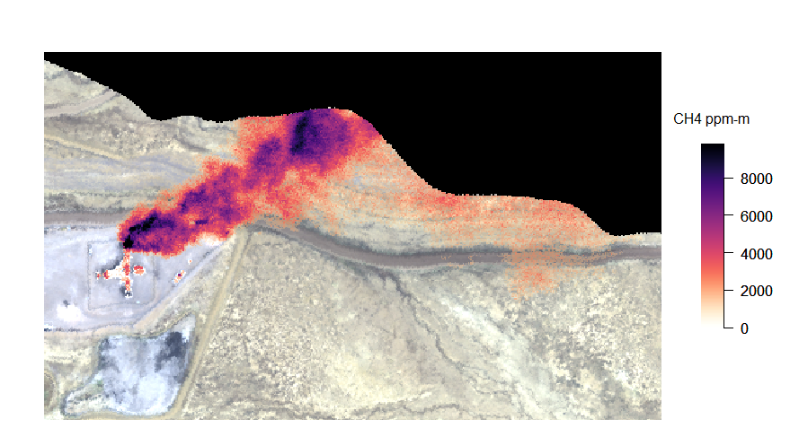
Figure 1. A methane plume emitted by a coal mine vent in scene ang20150420t181345. Methane concentration-path length enhancement (in ppm-m) is shown in the scale at right.

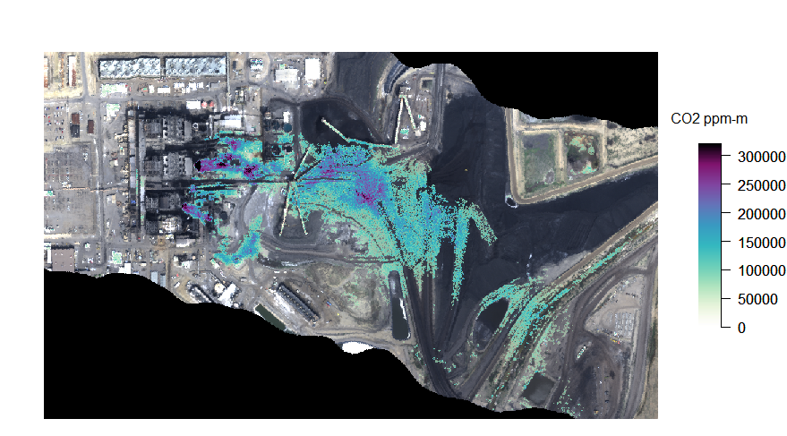
Figure 2. Carbon dioxide plumes emitted from a coal power plant in scene ang20150420t181345. Carbon dioxide concentration-path length enhancement (in ppm-m) is shown in the scale at right.

This scene was acquired west of Farmington, New Mexico, USA and contains both a methane plume from a coal mine vent (Figure 1) and carbon dioxide plumes from a coal power plant (Figure 2). This is the highest spatial resolution scene in the dataset, has the lowest column water vapor, and is the only scene containing both methane and carbon dioxide plumes.

Download [link for downloading ang20150420t181345]

ang20160211t075004
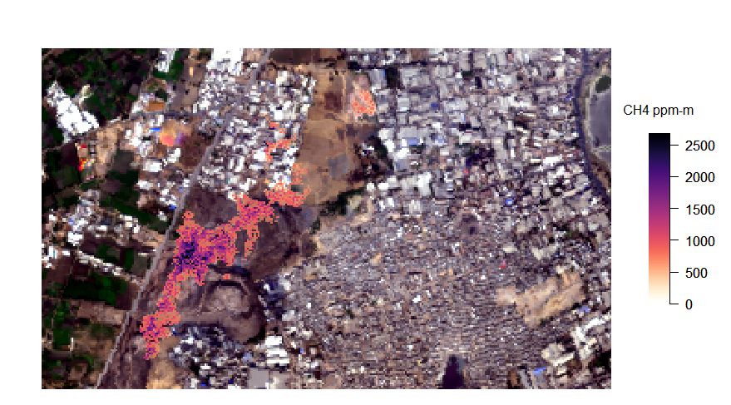
Figure 3. A methane plume emitted by the Pirana landfill in scene ang20160211t075004. Methane concentration-path length enhancement (in ppm-m) is shown in the scale at right.

This scene was acquired during the 2015-2016 NASA-ISRO AVIRIS-NG India Campaign, and contains the widest variety of methane sources in the dataset. The scene captures a large plume emitted by a landfill in Ahmedabad, Gujarat, India (Figure 3). Smaller plumes are associated with wastewater treatment plants and an oil well. This scene has the coarsest spatial resolution of methane scenes within the dataset.

Download [link for downloading ang20160211t075004]

ang20170616t212046
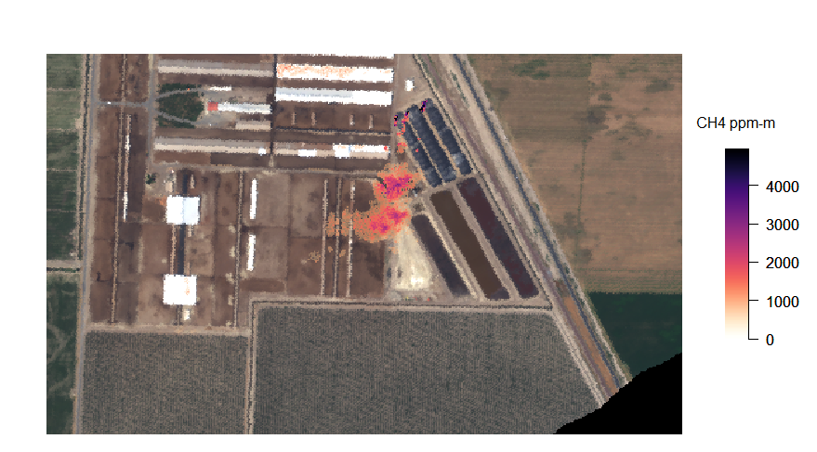
Figure 4. Methane plumes emitted by covered dairy feedlot waste lagoons in scene ang20170616t212046. Methane concentration-path length enhancement (in ppm-m) is shown in the scale at right.

This scene was acquired near Corcoran, California, USA and captures plumes emitted by dairy feedlot waste lagoons. In Figure 4, three plumes combine to one larger plume downwind.

Download [Link for downloading ang20170616t212046]

ang20170618t193955
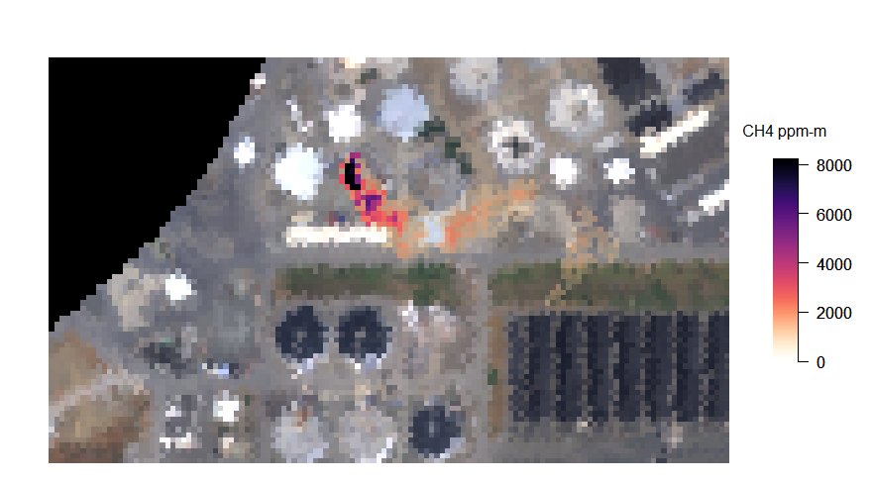
Figure 5. A methane plume emitted from a wastewater treatment plant in scene ang20170618t193955. Methane concentration-path length enhancement (in ppm-m) is shown in the scale at right.

This scene was acquired over San Jose, California, USA, and contains a plume from a wastewater treatment plant (Figure 5) and the downwind portion of a plume from the Newby Island Landfill. This scene complements ang20180927t195028, which includes both the treatment plant and the landfill source. This scene has the smallest solar zenith angle and the highest column water vapor in the dataset.

Download [Link for downloading ang20170618t193955]

ang20170906t210217
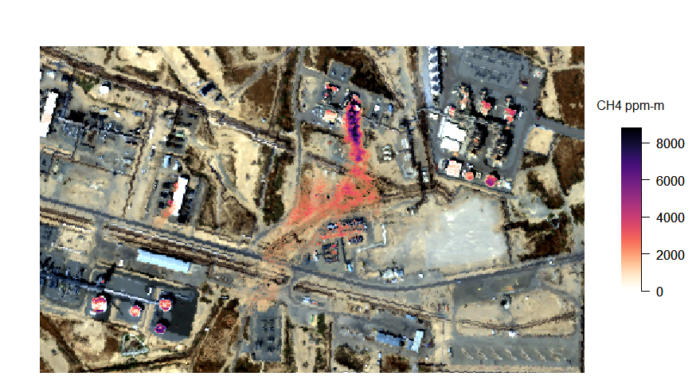
Figure 6. A methane plume emitted from natural gas infrastructure in scene ang20170906t210217. Methane concentration-path length enhancement (in ppm-m) is shown in the scale at right.

This scene was acquired over the Elk Hills oil and natural gas field in the San Joaquin Valley, California, USA. It contains methane plumes from natural gas infrastructure (Figure 6).

Download [Link for downloading ang20170906t210217]

ang20180415t045439
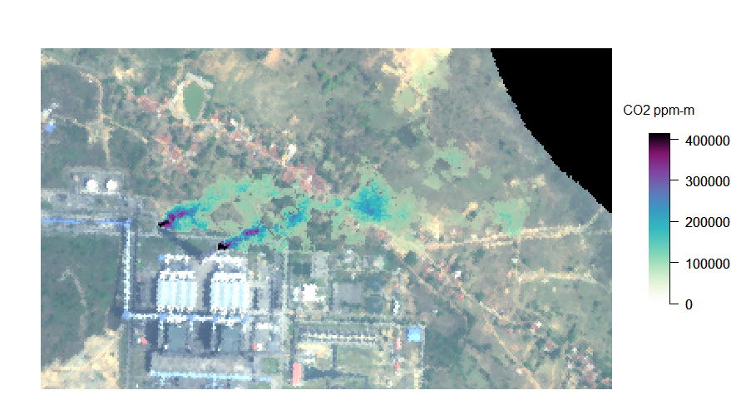
Figure 7. Power plant carbon dioxide plumes in scene ang20180415t045439. Carbon dioxide concentration-path length enhancement (in ppm-m) is shown in the scale at right.

This scene was acquired over Maithon, Jharkhand, India during the NASA-ISRO 2018 AVIRIS-NG Indian Campaign. The scene contains two carbon dioxide plumes emitted from coal power plant smokestacks (Figure 7).

Download [Link for downloading ang20180415t045439]

ang20180927t195028
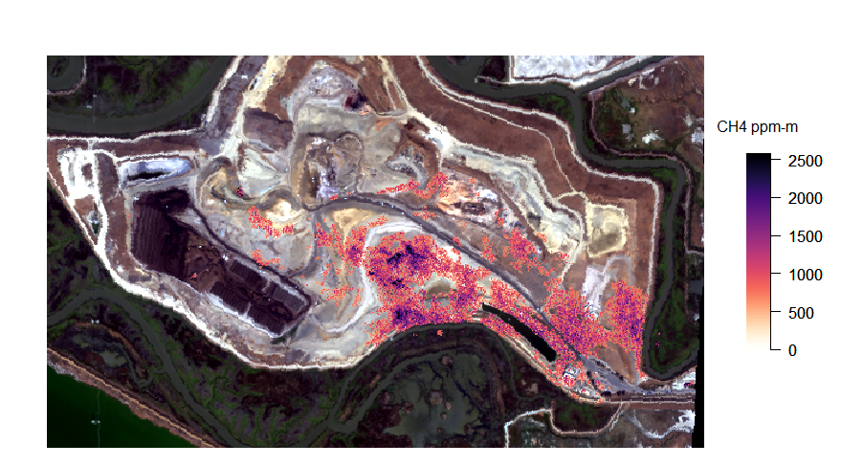
Figure 8. Methane enhancements over the Newby Island Landfill in scene ang20180927t195028. Methane concentration-path length enhancement (in ppm-m) is shown in the scale at right.

This scene was acquired over San Jose, California, USA. It includes methane emissions from the Newby Island Landfill (Figure 8) as well as a plume from a wastewater treatment plant. The scene complements scene ang20170618t193955, which includes plumes from the same two sources.

Download [Link for downloading ang20180927t195028]

ang20190621t200919
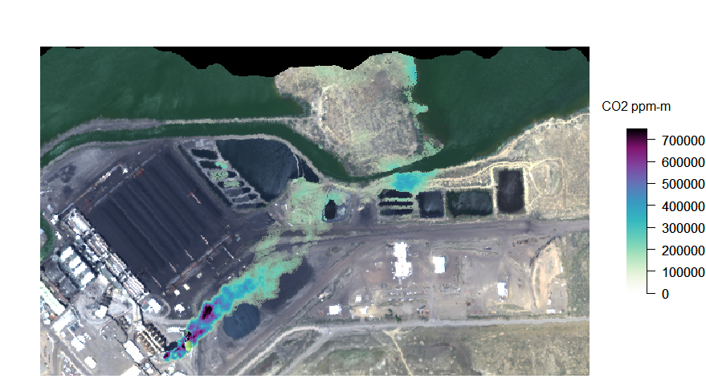
Figure 9. A carbon dioxide plume from a coal power plant in scene ang20190621t200919. Carbon dioxide concentration-path length enhancement (in ppm-m) is shown in the scale at right.

This scene was acquired west of Farmington, New Mexico, USA. It contains a carbon dioxide plume from the Four Corners coal power plant (Figure 9). This scene has the smallest solar zenith angle for carbon dioxide scenes within the dataset.

Download [Link for downloading ang20190621t200919]

ang20191004t221515
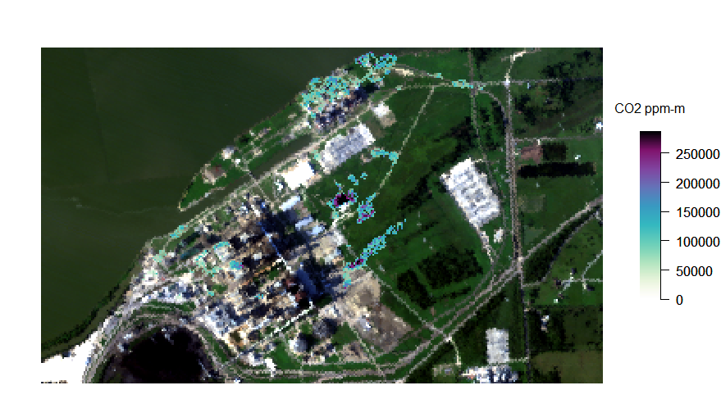
Figure 10. Carbon dioxide enhancements associated with coal and natural gas power plants in scene ang20191004t221515. Carbon dioxide concentration-path length enhancement (in ppm-m) is shown in the scale at right.

This scene was acquired over the W.A. Parish coal and natural gas power plants southwest of Houston, Texas, USA. Carbon dioxide enhancements are visible adjacent to smokestacks for the coal power plant (Figure 10, center) and over the natural gas plant (Figure 10, top center); however, there are no definitive, large, plume-like features in this scene when processed using the L1-sparse albedo-corrected matched filter described in Foote et al. (2020). This scene has the largest solar zenith angle within the dataset, and the coarsest spatial resolution.

Download [Link for downloading ang20191004t221515]

ang20191023t151141
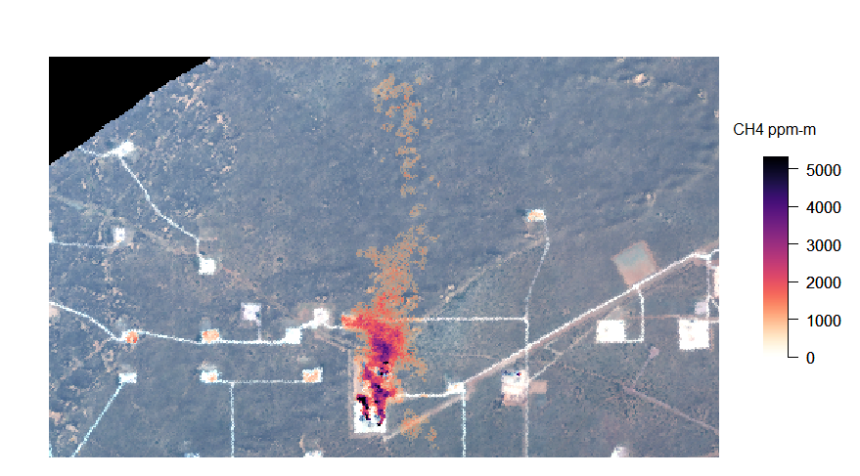
Figure 10. Methane plumes from natural gas infrastructure in scene ang20191023t151141. Methane concentration-path length enhancement (in ppm-m) is shown in the scale at right.

This scene was acquired over an oil and natural gas field near Carlsbad, New Mexico, USA, within the Permian Basin. Several methane plumes can be found within the scene. This scene has the largest solar zenith angle of methane scenes within the dataset.

Download [Link for downloading ang20191023t151141]

